Development - Photoresistor Evaluation
Experiment Description
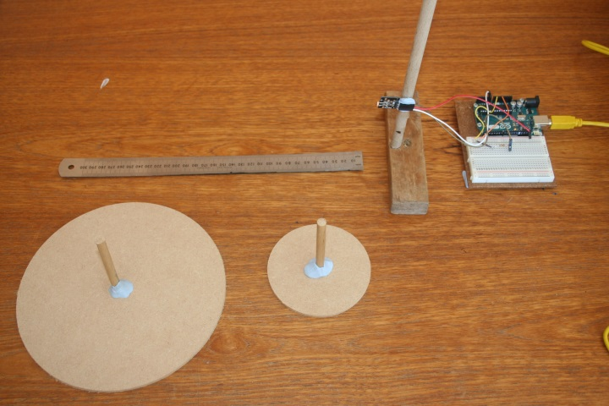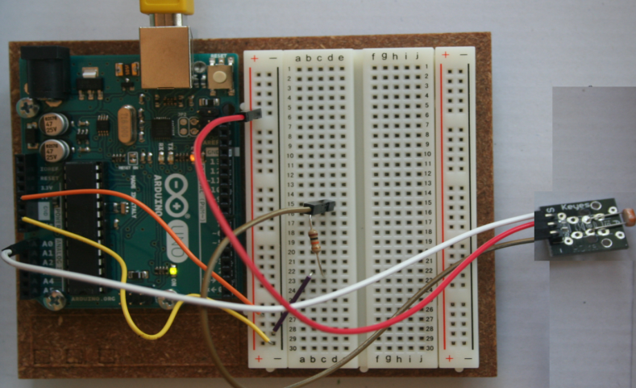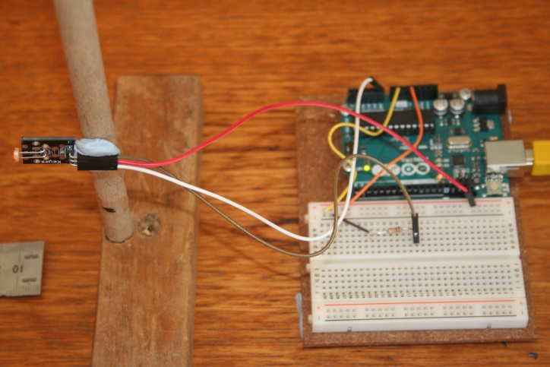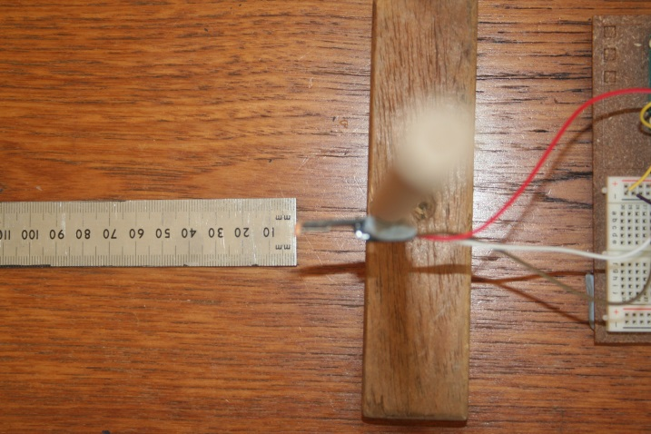
D
C
B
A
- An experiment was designed to determine if a photo resistor (Light dependant Resistor (LDR)) could be used to:
  - Test for the presence of a bird sized object on a bird table
  - Differentiate between different sized objects (e.g. a robin and a pigeon )
- Two different sized MDF circles of radii 50mm and 100mm were constructed to represent different sized birds (A)
- The photo resistor circuit was constructed (B)
- The photo resistor was attached to a pillar such that its height could be adjusted to match the centre of each circle (C)
- A ruler was used to measure the distance from the circle to the sensor (D)
- Using each circle in turn:
  - The light intensity (resistance) reading was taken (this value was subtracted from other readings to give the change in light intensity
  - The circle was located at a distance of 300mm from the sensor (perpendicular to it) and the change in light intensity calculated
  - The circle was moved towards the sensor in small steps, the reading taken, and the change in light intensity calculated (E/F)

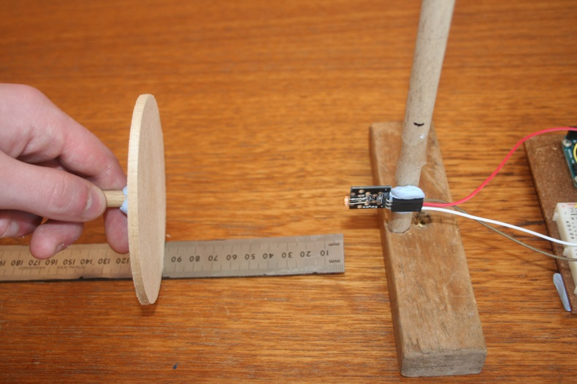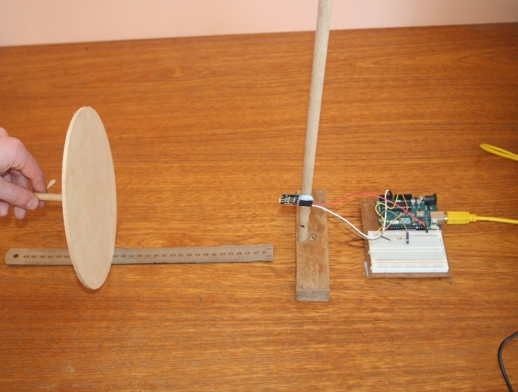
E
F
Circuit Diagram & Software
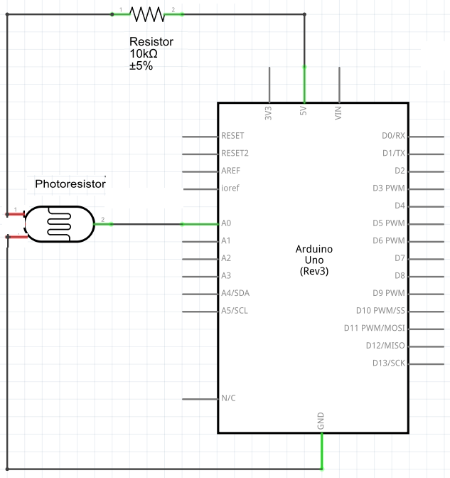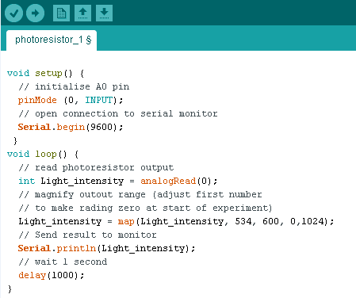
Results
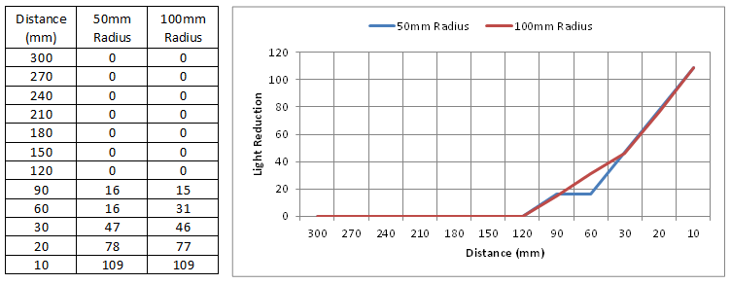

- The table and graph above show the results obtained
- The Light intensity (photo resistor resistance) changes were only detectable within a distance 90mm from the sensor
- The variation in light intensity from 90mm to 10mm was small
- No significant difference was found in light intensity change between circles of different size at a given distance
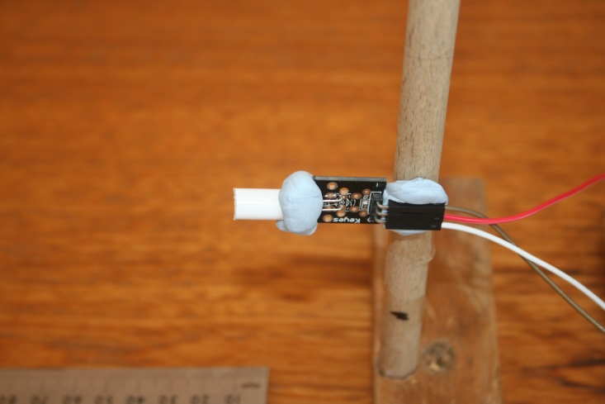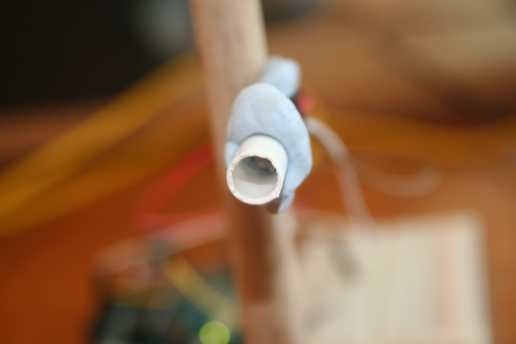
G
H
- The sensor appeared to be sensitive to light changes in all directions so a tube was attached to try and make it sensitive in one direction (G/H)
- The experiment was repeated but the results were the same

